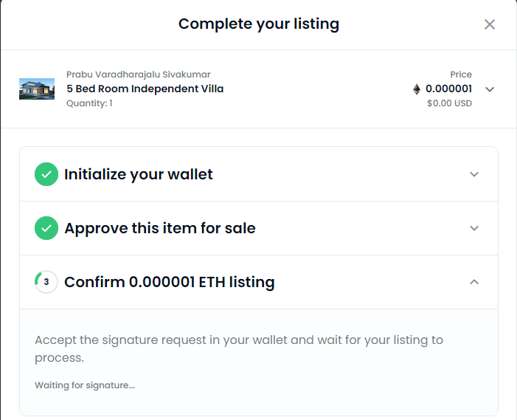



Switch to another account in the Meta Mask and ensure the account has sufficient funds to buy an item.

Now we see that Buy Now button is enabled for the same listing.

Now switch back to Account 1 (Originally used to list items) and see the activities listed below:

